# Setting up Active Directory

**Date built:** May 2026
**Virtualisation:** VirtualBox

## Goal
in this project I my goal was to install a virtual windows server and install active directory services role on the server

## What I installed
- VirtualBox server VM
- windows server 2022 iso
- Active Directory services and DNS
-configured IP address

## Step by step

### 1.
I Started by downloading a windows server 2022 iso

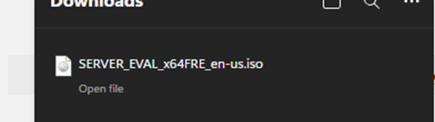

### 2. Then I opened virtualbox and started a new VM which I named DC01 i set the username to admin and the password to admin123!

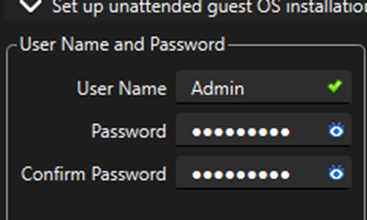
I set the base memory to 4500mb and 2 cpus disk size to 60.00gb
I then proceeded to start the VM but I ran into this problem
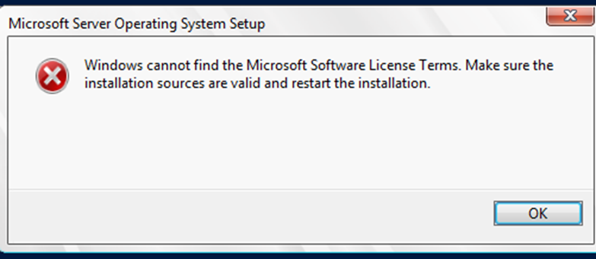
I noticed that I had installed it incorrectly, so I deleted the broken VM and created a new one I solved the problem then launched up my VM again.
Then I installed the Microsoft server OS on the VM

### 3. Then I installed the Microsoft server OS on the VM
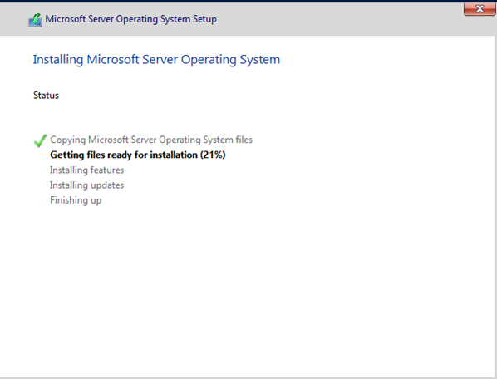
I set the password to Sitara1901
I logged in into the Servers OS I opened server manager then went on to local server to rename the server to DC1 this forced me to restart the server to which I complied logged back in opened server manager and saw name changed to DC1
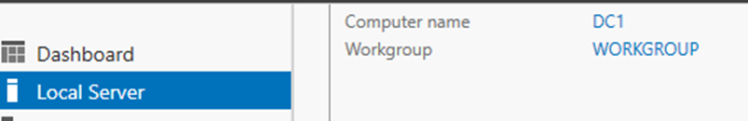

### 4. Next I decided to set a static ip address because a domain controller should not use a changing DHCP address
I opened the network and internet folder to see network connections I checked the properties and clicked on internet protocol version 4
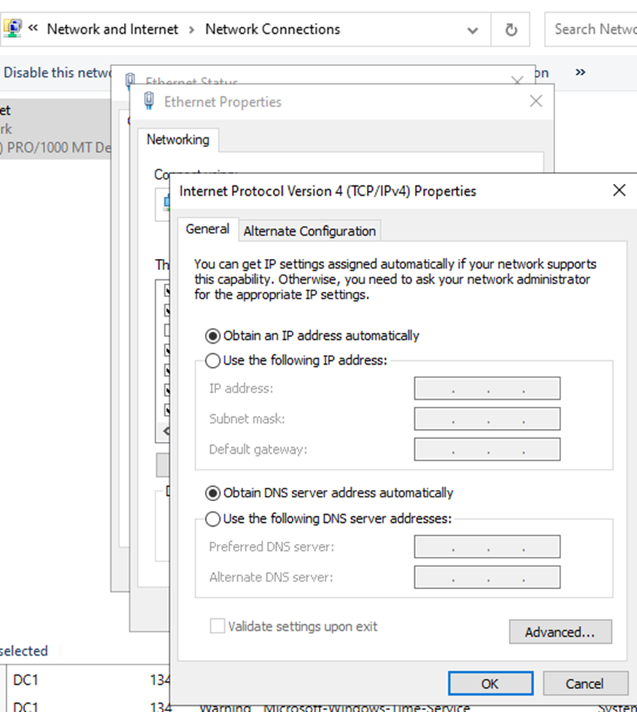
I set ip address to 192.168.56.10
Subnet mask to
255.255.255.0
And default Gateway to 192.168.56.1
Dns server to my VM server 192.168.56.10

###5. Now I will install active directory domain on the server, I added roles active directory and dns server
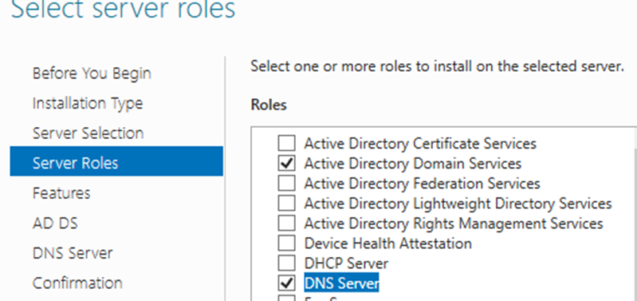
And then I installed it after that I promoted the server to the domain controller. In the deployment configuration tab I selected add new forest
I found out that forest means to create a brand new directory from scratch
I set the root domain name to corp.local
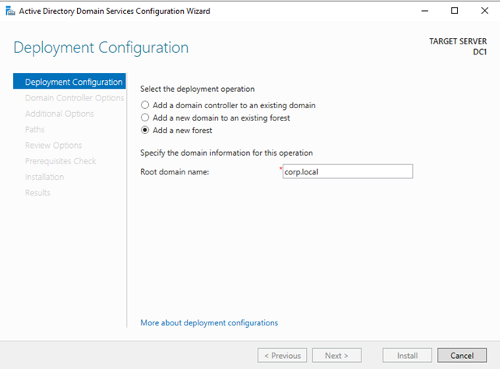

Next page took me to the domain controller options and I set the DSRM password to Sitara1901

## things I learned from this set-up
I learned how to install a server as a VM
I learned how to navigate through server manager
I understood how IP addressing would work on a server Active Directory
I learned how to add roles to a server like DNS,DHCP and ADS

## Problems I hit and how I fixed them
I installed the vm as unattended setup which give me an error so I decided to start fresh by deleting the VM and starting a new one and setting it up manually

## Next steps
Next I plan to add a DHCP role and add users and set passwords

